US Grade 9 – Pre-test
15 Questions | 60 minutes | Calculator allowed
1. $(3x^{4})^{2}$ simplified is
- $3x^{6}$
- $6x^{6}$
- $9x^{8}$
- $9x^{6}$

2. $7^{5}×7÷7^{3}$ written as a single power is
- $7^{3}$
- $7^{2}$
- $7^{9}$
- $7^{1}$

3. What value of $m$ makes the equation $\frac{6a^{m}}{2a^{3}}=3a^{5}$ true?
- $2$
- $8$
- $15$
- $18$
4. $5^{-2}$ is equal to
- $\frac{1}{25}$
- $\frac{1}{10}$
- $-10$
- $-25$

5. The formula for area of a triangle is $A=\frac{bh}{2}.$
Which is the formula rearranged to isolate $h$?
- $h=\frac{A}{2}+b$
- $h=\frac{b}{2A}$
- $h=\frac{A+2}{b}$
- $h=\frac{2A}{b}$

6. Expand and simplify $x(x-2)-4(x+1)$
- $2x+6$
- $x^{2}+2x-7$
- $-3x+7$
- $x^{2}-6x-4$

7. The graph below represents the relationship between Rena’s distance from home and time. In which section is Rena moving the fastest?
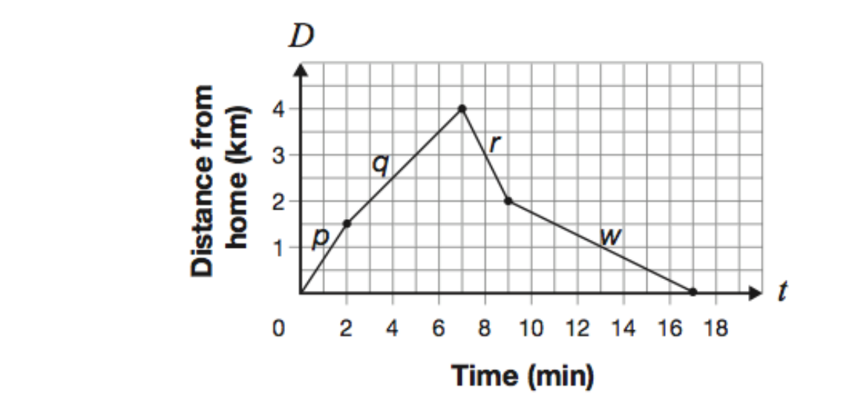
- p
- q
- r
- w

8. Identify the slope and y-intercept of$y=-3x+4$
- $m= -4 ; b=3$
- $m= 4 ; b=-3$
- $m= 3 ; b=4$
- $m= -3 ; b=4$

9. What is the slope of the line that passes through the points A(2,-6) and B(7,8)?
- $m=14/5$
- $m=5/14$
- $m=2/5$
- $m=-2/5$

10. Calculate the perimeter and area of the figure below
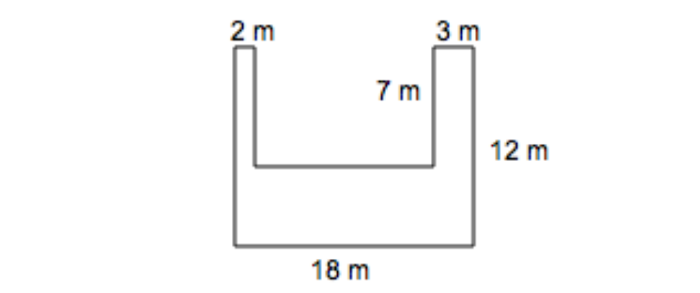
- $P=34m ; A=32m^{2}$
- $P=64m ; A=90m^{2}$
- $P=74m ; A=125m^{2}$
- $P=42m ; A=216m^{2}$

11. The length of a rectangle is 3 cm more than double the width.
The perimeter of the rectangle is 96 cm.
What are the length of the rectangle?

____________________ cm

12. Find the equation for a line that is parallel to the line$4x+5y+2=0$ and goes through the point (5,-3)

$y=$ ____________________

13. Find the surface area of
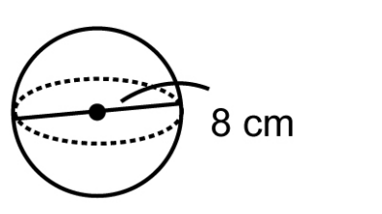

_____________________ $cm^{2}$

14. Solve for $x$
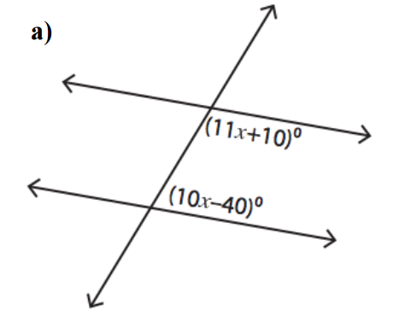

$x=$____________________

15. Solve for the missing side of each triangle




